SKILL-11
- To Store Commands, Maintain History Buffer, Handle Capacity Limits, Retrieve Entries, Display History, Validate Consistency.
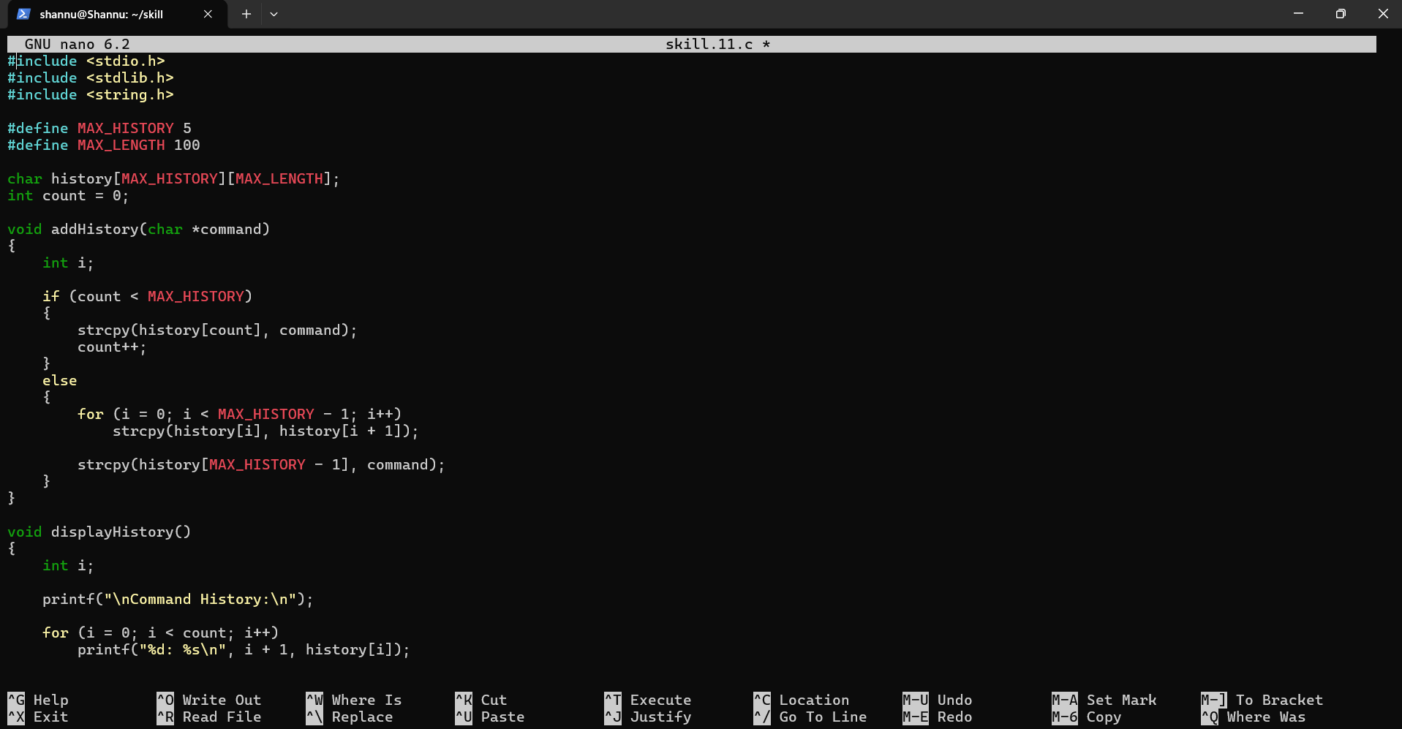
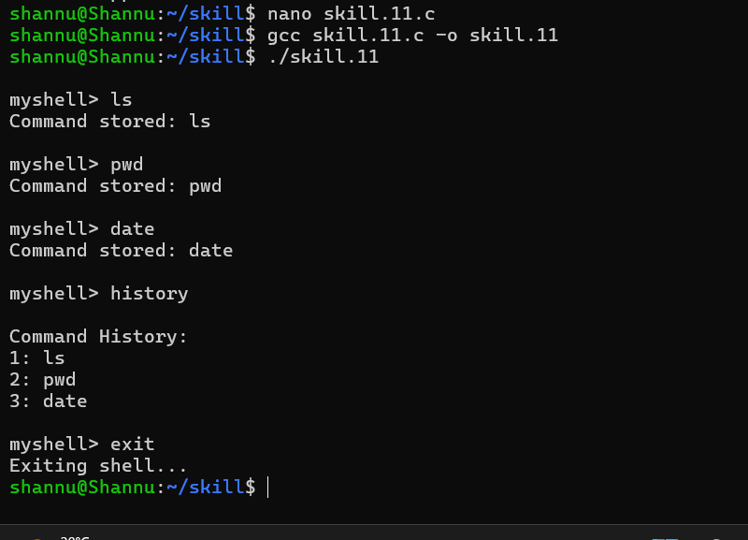
To Create Pipeline Structures, Store Commands, Maintain Execution Order, Connect Processes, Validate Pipeline Layout, Test Configurations.
